Title: The title should be comprehensive, precise, and sufficiently expanded to clearly reflect the scope, methodology, context, and key contribution of the manuscript.

Name Surname^{,2}, Name Surname³, Name Surname⁴, Name Surname⁵, Name Surname^{1*}

¹Educational and Scientific Institute of Neurosurgery, Рeoples' Friendship University of Russia (RUDN University), 6 Miklukho-Maklay Str., 117198, Moscow, Russia
²Pirogov Russian National Research Medical University, Ministry of Healthcare of Russian Federation, 1 Ostrovityanov Str., 117997, Moscow, Russia
³Department of Neurosurgery, First Affiliated Hospital of Harbin Medical University, Heilongjiang Province, 150001, Harbin, P.R. China
⁴Moscow Hertsen Research Institute of Oncology, Branch of the National Medical Radiology Research Center, Ministry of Health of Russian Federation, 125284, Moscow, Russia
⁵Sechenov First Moscow State Medical University, 2 Bol'shaya Pirogovskaya Str., 119435, Moscow, Russia

*For correspondence: obeylerli@mail.ru

Abstract (150-250 words)

Brain tumor therapy with anti-vascular endothelial cell growth factor (VEGF) agents/drugs is a therapeutic approach aimed at inhibiting the growth of new blood vessels that feed the tumor. This method, often referred to as targeted therapy, uses drugs that block the action of VEGF, which slows tumor growth and neovascularization. This study analyzes existing clinical trials registered on the ClinicalTrials.gov website on the therapeutic use of anti-VEGF agents in the treatment of brain tumors. As of December 2025, approximately 65 registered clinical trials on the use of anti-VEGF agents in the treatment of brain tumors, including gliomas, meningiomas, schwannomas, medulloblastomas (adult and pediatric), ependymomas, and metastatic brain tumors, were posted on ClinicalTrials.gov. Furthermore, recurrent tumors were also studied. However, full results have been published for only 16 clinical trials demonstrating the safety and efficacy of anti-VEGF agents. The results of these clinical trials open new horizons for the latest methods of targeted therapy for brain tumors.

Keywords: Brain tumors, vascular endothelial cell growth factor, clinical trials, targeted therapy, personalized medicine, complications

INTRODUCTION

Antiangiogenic agents are among the most commonly used antitumor agents/drugs in brain tumor therapy in clinical practice today. The most commonly used antiangiogenic drugs are those that target vascular endothelial cell growth factor (VEGF) (Chekhonin et al., 2013; Beylerli et al., 2025). The question of whether certain anti-VEGF drugs can be used clinically largely depends on the approval of certain regulatory authorities. It is known that the possibility of using certain drugs in clinical practice usually comes from approval by regulatory agencies such as the U.S. Food and Drug Administration (FDA) or the European Medicines Agency (EMEA) (Kang et al., 2024). It should be noted that rigorous regulatory review is typically limited to large Phase 3 clinical trials. The adoption of modern efficacy endpoints such as survival (OS), progression-free survival (PFS), or response rate (RR) can be complicated by many factors. These include access to the same or similar treatment protocol, in which case the question may not simply be whether a new drug should be used earlier or later than a standard comparator. Clinical efficacy and toxicity may also depend on the use of concomitant chemotherapy or radiation therapy or a combination of both the patient's tumor and non-cancerous conditions that the patient also has, particularly in older patients (Niazi SK., 2024; Pisarska et al., 2019; Roda et al., 2024). Despite this complexity, anti-VEGF therapy has established itself as one of the most important classes of drugs for the treatment of oncological diseases, including brain tumors. The study aims to analyze the current possibilities of using anti-VEGF drugs in the treatment of brain tumors in clinical settings, as well as the possible side effects of use.

MATERIALS AND METHODS

Search strategy: We conducted a comprehensive search for clinical trials demonstrating the use of anti-VEGF agents in the treatment of brain tumors, alone or in combination with chemoradiation.

Fig. 1. Main anti-vascular endothelial growth factor (VEGF) agents in brain tumor treatment. The mechanism of action of some (e.g., bevacizumab) is based on binding to VEGF-A/B/C ligands and preventing their interaction with their receptors (VEGFR-1/2/3) on the surface of endothelial cells (ECs) of the GBM vessels. Others (e.g., ramucirumab) specifically bind to VEGF receptors and block the binding of the VEGF receptor to the VEGF-A/B/C ligands. Adapted from Beylerli et al. (Beylerli et al., 2025).

The clinicaltrials.gov database was used to retrieve all relevant information on ongoing clinical trials (Guelfi et al., 2024). The search was based on key words, specifically, in the Condition/disease search section, we used “brain tumors,” “glioma,” “glioblastoma,” “meningioma,” “medulloblastoma,” “schwannoma,” “ependymoma,” and “brain metastasis,” and in the Intervention/treatment search section, we used “vascular endothelial growth factor” and “VEGF.” The following inclusion and exclusion criteria were used to select studies, divided into two stages (Figure 2).
Statistical Analysis: The t-test, ANOVA, chi-square analysis, or Mann-Whitney test were used. A p-value of < 0.05 (*), < 0.01 (**), or < 0.001 (**) was considered statistically significant. Statistical analysis was performed using IBM SPSS 22.0 software, and graphs were generated using Graphpad Prism 8.0.

RESULTS AND DISCUSSION

The use of anti-VEGF agents is a relatively new area with great potential to address many serious problems in neurosurgery and oncology (Beylerli et al., 2025; Pellerino et al., 2023; Pan et al., 2024). While further research may be required to fully exploit this potential, significant progress has already been made in studying the efficacy of anti-VEGF agents (Figure 3).
At the time of this study (December 2025), 65 clinical trials using anti-VEGF agents in the treatment of brain tumors were registered worldwide (note: some studies examined two or more tumor types) (Figure 4).
The number of registered clinical trials has increased significantly since the first official use of the anti-VEGF agent bevacizumab (recombinant hyperchimeric monoclonal IgG1 antibody) in the treatment of recurrent glioblastoma was reported on Clinicaltrials.gov on January 2, 2006 (Figure 5).
After applying the inclusion and exclusion criteria in Stage 1 of our study, a total of 23 clinical trials were excluded because they were either in early Phase 1, had no Phase specified, had an inapplicable Phase, or had been withdrawn (Figure 6A). We analyzed the remaining 42 clinical trials by their field of study, Phase, status, and location (Figures 6B-C).

Fig. 2. Flow chart of study design.

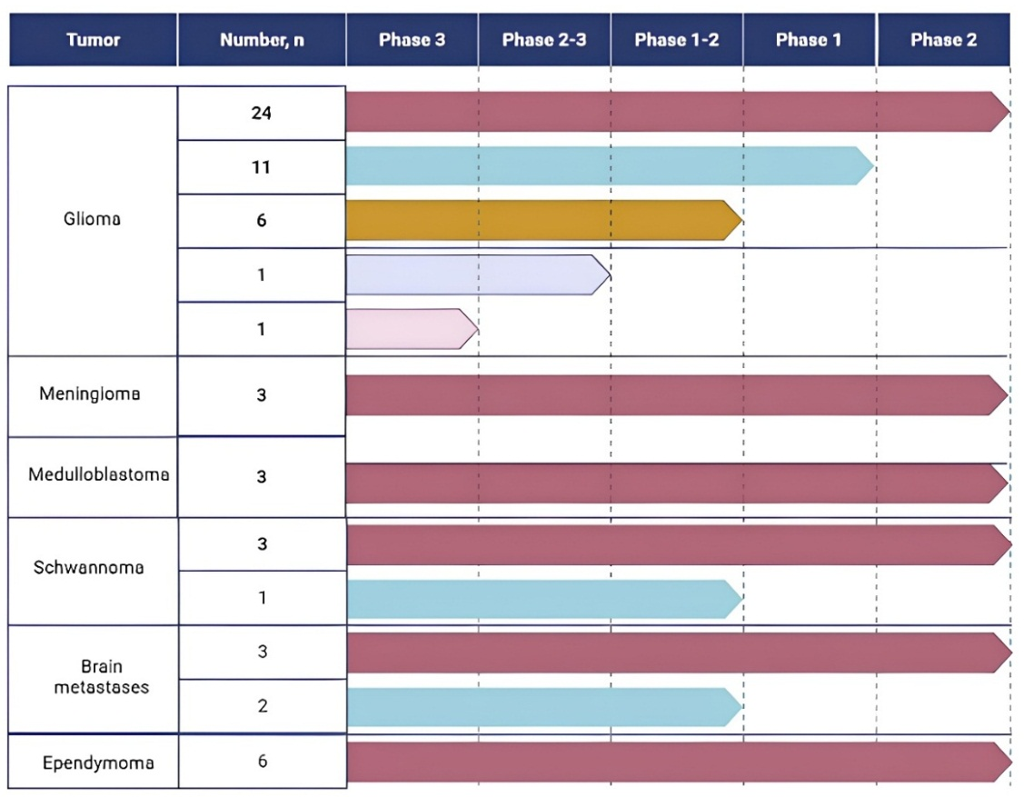

Fig. 3. Distribution of clinical trials by main brain tumors studied and by clinical Phases.

Fig. 4. Distribution of the number of clinical trials in descending order.

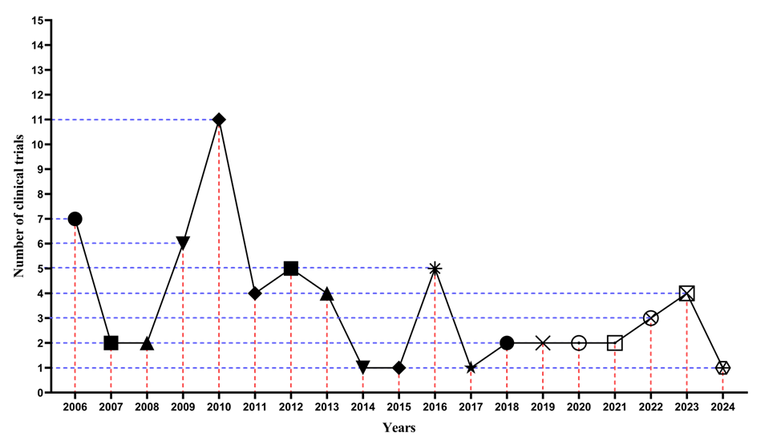

Fig. 5. Statistics of registered clinical trials for testing clinical potential in accordance with the dynamics of temporary (annual) registrations from the start and registration of the first clinical trial, based on data from the Clinicaltrials.gov website.

One clinical trial, NCT00985036, included a study of gliomas and meningiomas that did not specify a Phase and had a withdrawn status. The 42 clinical trials using anti-VEGF agents in our analysis are currently ongoing in 18 countries (note: some studies included treatment or research centers/institutions in two or more countries) (Figure 7). The United States, Canada, China, Germany, Israel, and Australia led the number of clinical trials.
Only 19 clinical trials using anti-VEGF agents alone or in combination with chemoradiation were selected for Phase 2 because they met the stated criteria for this study, namely, having a "Completed" status and published results. All of these clinical trials were primarily in Phase 2, primarily using bevacizumab alone or in combination with chemoradiation. Furthermore, glioma studies accounted for the largest number of clinical trials. The clinical trials showed positive results without serious side effects (Table 1).

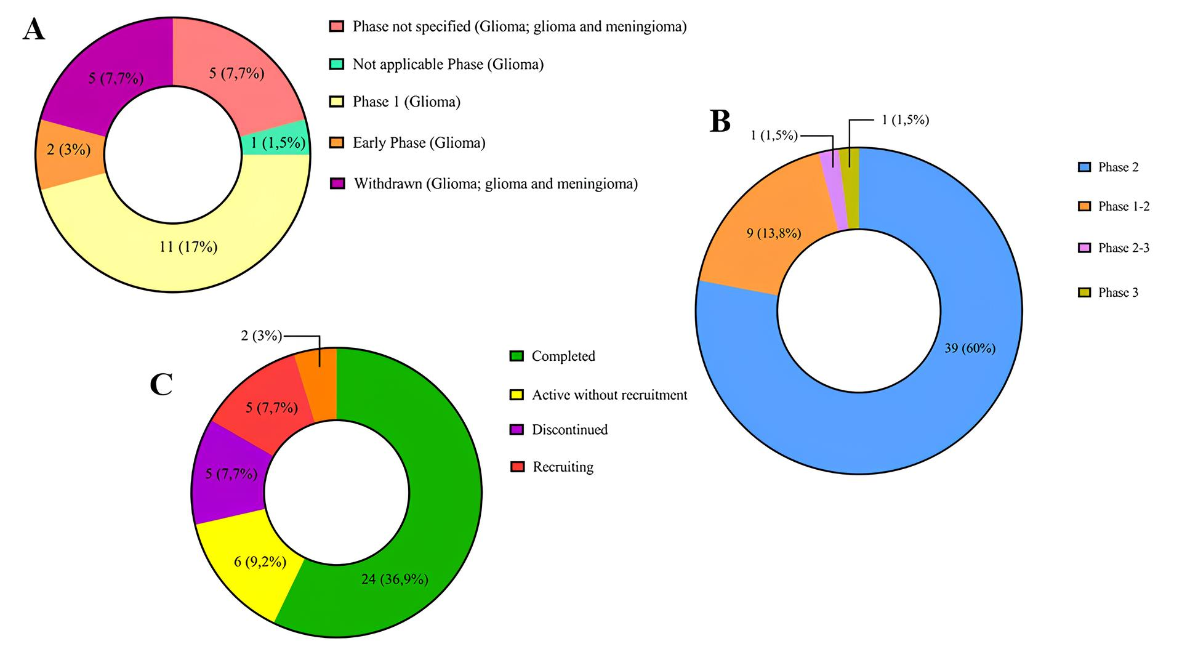

Fig. 6. Distribution of clinical trials. (A) Proportion of excluded clinical trials by Phase and Status. (B) Proportion of included clinical trials by Phase and (C) Proportion of included clinical trials by Status.

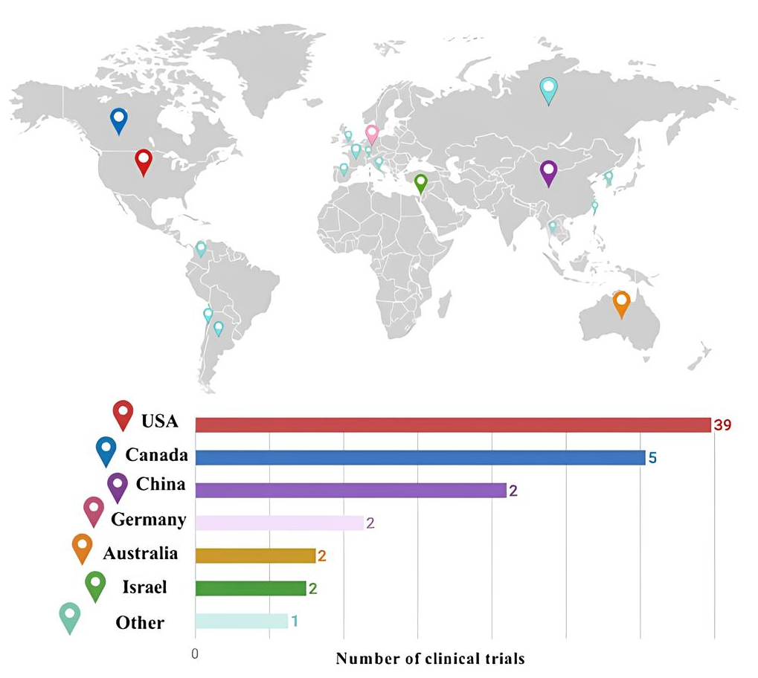

Fig. 7. Geographical distribution.
Table 1. Distribution of the most effective clinical trials (with a status of “Completed” and with results) registered on Clinicaltrial.gov as of December 2025 using vascular endothelial growth factor (VEGF) blocking drugs for the treatment of brain tumors.
NCT number | Tumor type | Therapy
NCT00369590 (Phase 2) | Glioma | Ziv-aflibercept
NCT00271609 (Phase 2) | Glioma | Bevacizumab
NCT00381797 (Phase 2) | Glioma | Bevacizumab + Fludeoxyglucose F-18 + Irinotecan hydrochloride
NCT01648348 (Phase 1–2) | Glioma | Anti-endoglin chimeric monoclonal antibody TRC105 + Bevacizumab
NCT01067469 (Phase 2) | Glioma | Bevacizumab (standard dose and low dose) + Lomustine
NCT00329719 (Phase 1–2) | Glioma | Sorafenib tosylate + Temsirolimus + Traditional surgery
NCT00433381 (Phase 2) | Glioma | Bevacizumab + Irinotecan hydrochloride + Temozolomide
NCT01236560 (Phase 2–3) | Glioma | Bevacizumab + Temozolomide + Vorinostat
NCT01730950 (Phase 2) | Glioma | Bevacizumab + Radiation Therapy
NCT01609790 (Phase 2) | Glioma | Bevacizumab + Trebananib
NCT00884741 (Phase 3) | Glioma | 3-dimensional conformal radiation therapy + Bevacizumab + Intensity-modulated radiation therapy + Temozolomide
NCT00492089 (Phase 2) | Glioma, ependymoma and meningioma | Bevacizumab
NCT01753713 (Phase 2) | Glioma | Dovitinib
NCT01125046 (Phase 2) | Meningioma, schwannoma and ependymoma | Bevacizumab
NCT00883688 (Phase 2) | Ependymoma | Bevacizumab + Lapatinib
NCT01217437 (Phase 2) | Medulloblastoma | Bevacizumab + Irinotecan hydrochloride + Temozolomide
NCT01898130 (Phase 2) | Metastases | Bevacizumab
NCT01767792 (Phase 2) | Schwannoma | Bevacizumab
NCT01125046 (Phase 2) | Schwannoma | Bevacizumab

Anti-VEGF agents are widely used in the treatment of tumors but are associated with a characteristic set of complications due to the blockade of angiogenesis. The most common and clinically significant side effect is hypertension, which develops due to decreased nitric oxide production and increased vascular resistance. Anti-VEGF agents also damage the renal glomeruli, which is manifested by proteinuria and, in rare cases, nephrotic syndrome.

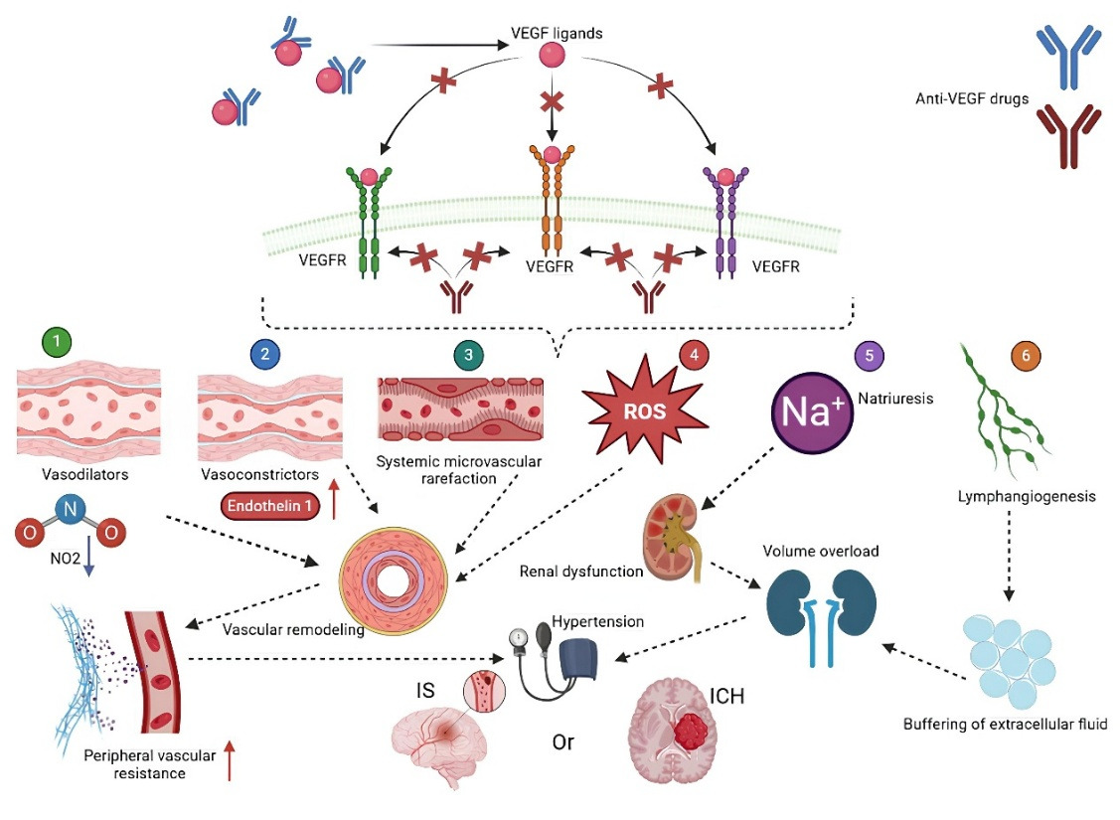

Fig. 8. Schematic illustration of the mechanism of development of arterial hypertension after the use of anti-vascular endothelial growth factor (VEGF) therapy in brain tumors. Adapted from Beylerli et al. (Beylerli et al., 2025).
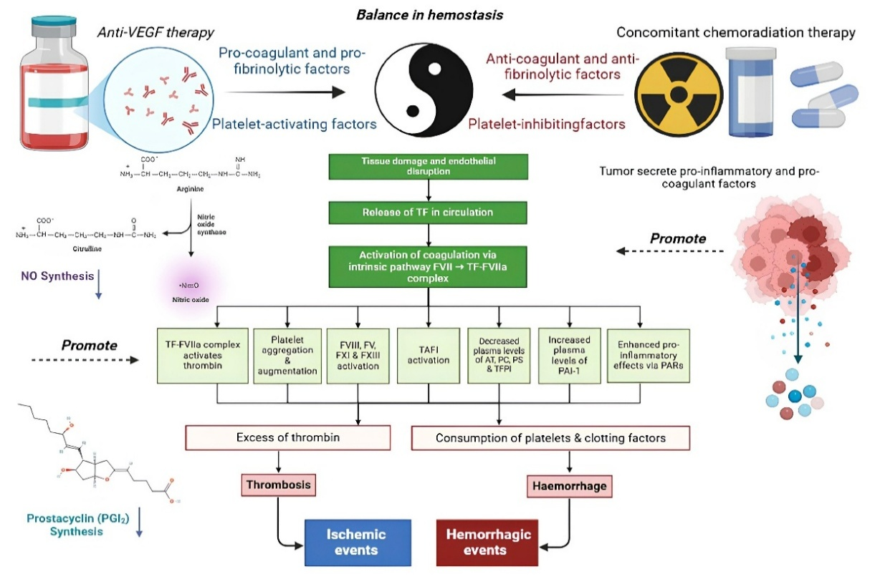

Fig. 9. Mechanism of influence of anti-vascular endothelial growth factor (VEGF) agents on hemostasis. Adapted from Beylerli et al. (Beylerli et al., 2025).

Table 2. The presence of the most serious adverse events that were detected as a result of anti- vascular endothelial growth factor (VEGF) therapy.
NCT number | Serious adverse events
NCT00369590 (Phase 2) | Oral hemorrhage and brain ischemia
NCT00271609 (Phase 2) | brain ischemia and hemorrhage, seizure proteinuria and thrombosis/thrombus/embolism
NCT00381797 (Phase 2) | Alanine aminotransferase increased, neutrophil and platelet count decreased, hypoalbuminemia, hypocalcemia, hyponatremia, hydrocephalus, seizure, hypertension and intracranial hemorrhage
NCT01648348 (Phase 1–2) | Thrombosis
NCT01067469 (Phase 2) | Fracture, muscle weakness – generalized, brain ischemia, confusion and headache
NCT00329719 (Phase 1–2) | Lymphocyte count, neutrophil and platelet decreased, serum triglycerides increased, leukoencephalopathy, peripheral motor neuropathy and seizure
NCT00433381 (Phase 2) | Hemoglobin, hemorrhagic stroke, leukopenia, lymphopenia, neutrophil and platelet count decreased, abdominal pain, colonic perforation, constipation, chest pain, fatigue, aspartate aminotransferase increased, convulsions and thrombosis
NCT01236560 (Phase 2–3) | Hydrocephalus
NCT01730950 (Phase 2) | Encephalopathy, seizure, hematoma and thromboembolic event
NCT01609790 (Phase 2) | Cognitive disturbance, seizure and stroke
NCT00884741 (Phase 3) | Lymphopenia, leukopenia, retinal detachment, blurred vision, abdominal pain, constipation, nausea, fever, neutrophil and platelet count decreased, hyperglycemia, muscle weakness, cognitive disturbance, intracranial hemorrhage, ischemic cerebrovascular, peripheral motor neuropathy, seizure
NCT00492089 (Phase 2) | Thrombosis
NCT01753713 (Phase 2) | Confusion and thrombosis
NCT01125046 (Phase 2) | Seizure
NCT00883688 (Phase 2) | Increase serum glutamic pyruvic transaminase (ALT, SGPT), cranial neuropathy CN IX, motor apnea and dyspnea
NCT01217437 (Phase 2) | Sepsis and hypotension
NCT01898130 (Phase 2) | Seizure
NCT01767792 (Phase 2) | Headache
NCT01125046 (Phase 2) | Seizure

VEGF inhibitors are associated with an increased risk of vascular events, including ischemic and hemorrhagic stroke, due to endothelial dysfunction, increased hypertension, and thrombotic complications (with some drugs, the risk of arterial thrombosis is higher than venous) (Figure 8 and Figure 9) (Beylerli et al., 2025; Katsi et al., 2014; Tonooka et al., 2022; Soffietti et al., 2012; Ferroni et al., 2010). Hemorrhagic strokes are less common, but the risk increases with the combination of anticoagulants or coagulation disorders (Zaborowska-Szmit et al., 2020). The risk of complications is highest in patients with pre-existing cardiovascular disease, uncontrolled hypertension, older age, or diabetes, so regular monitoring of blood pressure and risk factors is necessary.
One of the serious, albeit relatively rare, complications is gastrointestinal perforation and fistula development, especially in tumors that invade the intestinal wall. Anti-VEGF agents significantly delay wound healing, so they are often discontinued well before surgery and resumed only after complete healing (Min et al., 2021; Schiffmann et al., 2019). The frequency and severity of complications depend on the specific drug, dose, concomitant therapy, and the patient's comorbidities. Their prevention and management require regular blood pressure monitoring, urine protein testing, cardiac function assessment, and close monitoring for bleeding symptoms and abdominal pain. Early discontinuation or dose adjustment if serious toxicities occur, a multidisciplinary approach, and patient education about signs requiring immediate medical attention are essential (Table 2).
Clinical trials of anti-VEGF therapies for brain tumors are actively underway. The leading drug in this field is Bevacizumab, which blocks VEGF-A and prevents the formation of new blood vessels. It has demonstrated efficacy in reducing tumor volume and improving symptoms in patients with recurrent gliomas. In randomized trials, Bevacizumab improves short-term survival rates and quality of life. However, the long-term benefits of this treatment remain debated, as the effect is often short-lived. Many patients receive a combination of anti-VEGF agents and chemotherapy to enhance the effectiveness of the therapy. Studies are currently underway to combine anti-VEGF therapies with immunotherapy and other new treatments. The use of such combinations helps reduce the risk of brain tumor resistance to monotherapy, a significant advantage. The combined use of anti-VEGF agents with chemotherapy or immunotherapy enhances the antitumor effect and promotes longer-term stabilization of the patient's condition. This approach not only improves quality of life but also increases overall survival. Combination regimens allow for more precise tailoring of treatment to the individual patient and tumor characteristics. Furthermore, appropriately selected combination agents can reduce dosages and reduce side effects, improving treatment safety. Research shows that combinations of anti-VEGF agents with newer drugs can promote more effective destruction of cancer cells and prevent their recurrence. However, additional clinical trials are needed to identify optimal regimens, doses, and timing of such combinations. In the future, the combination of anti-VEGF agents with other drugs may become a standard in brain tumor therapy, providing longer-term disease control. It is important to continue to study and improve these methods to improve their effectiveness and safety.
Despite the significant advantages of anti-VEGF drugs in the treatment of brain tumors, they also have a number of limitations. One of the main ones is the development of therapy resistance, when the tumor adapts to anti-VEGF agents and continues to grow. Other disadvantages include a short period of effectiveness, followed by disease progression. Many patients experience side effects such as hypertension, bleeding, thrombosis, and vascular damage. Treatment sometimes causes a deterioration in general condition or complications associated with impaired wound healing and vascular problems. Furthermore, anti-VEGF agents can reduce quality of life due to their side effects and the need for long-term treatment. Another limitation is their cost, which often makes them unaffordable for some patients. There are also limitations in their effectiveness for certain tumor types or in certain patient groups. Finally, the use of anti-VEGF agents in combination with other treatments may increase the risk of adverse reactions and complications.
Overall, anti-VEGF agents are an important part of the treatment of brain tumors, but they are not intended to be curative. Research is ongoing to develop more effective drugs and improve treatment outcomes. New combinations and personalized approaches to treating brain tumors are expected in the future.

CONCLUSION

Angiogenesis is a complex molecular process that remains incompletely understood. These clinical studies have demonstrated that anti-VEGF agents, both alone and in combination with chemoradiation therapy, may be effective in the treatment of malignant brain tumors. Based on the results of 19 completed clinical trials, anti-VEGF agents are associated with prolonged PFS and a reduction in vasogenic cerebral edema. Larger multicenter prospective studies are underway to confirm these results and assess their impact on patient survival. These studies are being conducted in more than ten countries, including Russia (NCT03797326). Unfortunately, treatment failure inevitably occurs in the majority of patients. Further research is needed to identify other pro-angiogenic signaling pathways. Furthermore, combining anti-VEGF agents with immunotherapy may prevent the development of treatment resistance and maximize survival. New neuroimaging methods are needed to accurately assess tumor response to anti-VEGF therapy. However, inhibition of angiogenesis is a promising therapeutic approach that may have a significant impact on the treatment of both primary and metastatic brain tumors.

Ethical Considerations
This study complies with internationally accepted research ethics standards. No human participants, personal data, or confidential information were involved, or all ethical approvals were obtained where required.

Author Contributions
All authors contributed significantly to the conception, design, analysis, and writing of this manuscript. All authors have read and approved the final version and agree to be accountable for the content of the work.

Acknowledgements
The authors would like to thank all individuals and institutions that provided support or insights during the preparation of this study.

Funding
This research did not receive any specific grant from funding agencies in the public, commercial, or not-for-profit sectors.
(Or specify funding source if applicable.)

Conflict of Interest
The authors declare no conflict of interest related to this study.

References
References should be formatted according to APA 7th edition and listed alphabetically. All cited sources must be included, and all listed references must be cited in the text.

REFERENCES

Chekhonin V.P., Shein S.A., Korchagina A.A., Gurina O.I. (2013) VEGF in tumor progression and targeted therapy. Curr. Cancer Drug. Targets, 13(4): 423-443;
doi: 10.2174/15680096113139990074.
Beylerli O., Gareev I., Kaprin A., Ahmad A., Chekhonin V., Yang S., Yang G. (2025) Hemorrhagic and ischemic risks of anti-VEGF therapies in glioblastoma. Cancer Gene Ther., 32(7): 762-777; doi: 10.1038/s41417-025-00914-8.
Kang Y., Li H., Liu Y., Li Z. (2024) Regulation of VEGF-A expression and VEGF-A-targeted therapy in malignant tumors. J. Cancer Res. Clin. Oncol., 150(5): 221; doi: 10.1007/s00432-024-05714-5.
Niazi S.K. (2024) The United States Food and Drug Administration's Platform Technology Designation to Expedite the Development of Drugs. Pharmaceutics, 16(7): 918; doi: 10.3390/pharmaceutics16070918.
Pisarska M.D., Chan J.L., Lawrenson K., Gonzalez T.L., Wang E.T. (2019) Genetics and epigenetics of infertility and treatments on outcomes. J. Clin. Endocrinol. Metab., 104(6): 1871-1886; doi: 10.1210/jc.2018-01869.
Roda D., Veiga P., Melo J.B., Carreira I.M., Ribeiro I.P. (2024) Principles in the management of glioblastoma. Genes (Basel), 15(4): 501; doi: 10.3390/genes15040501.
Guelfi S., Hodivala-Dilke K., Bergers G. (2024) Targeting the tumour vasculature: from vessel destruction to promotion. Nat Rev Cancer., 24(10): 655-675; doi: 10.1038/s41568-024-00736-0.
Beylerli O., Gareev I., Musaev E., Ilyasova T., Roumiantsev S., Chekhonin V. (2025) Angiogenesis and resistance mechanisms in glioblastoma: targeting alternative vascularization pathways to overcome therapy resistance. Curr. Pharm. Des., Jul 22; doi: 10.2174/0113816128367551250703122830.
Pellerino A., Bruno F., Soffietti R., Rudà R. (2023) Antiangiogenic therapy for malignant brain tumors: Does it still matter? Curr. Oncol. Rep., 25(7): 777-785; doi: 10.1007/s11912-023-01417-1.
Pan X., Li X., Dong L., Liu T., Zhang M., Zhang L., Zhang X., Huang L., Shi W., Sun H., Fang Z., Sun J., Huang Y., Shao H., Wang Y., Yin M. (2024) Tumour vasculature at single-cell resolution. Nature, 632(8024): 429-436; doi: 10.1038/s41586-024-07698-1.
Katsi V., Zerdes I., Manolakou S., Makris T., Nihoyannopoulos P., Tousoulis D., Kallikazaros I. (2014) Anti-VEGF anticancer drugs: Mind the hypertension. Recent Adv. Cardiovasc. Drug Discov., 9(2): 63-72; doi: 10.2174/1574890110999150604114127.
Tonooka A, Ohashi R. (2022) Current trends in anti-cancer molecular targeted therapies: Renal complications and their histological features. J. Nippon. Med. Sch., 89(2): 128-138; doi: 10.1272/jnms.JNMS.2022_89-221.
Soffietti R., Trevisan E., Rudà R. (2012) Targeted therapy in brain metastasis. Curr. Opin. Oncol., 24(6): 679-686. doi: 10.1097/CCO.0b013e3283571a1c.
Ferroni P., Formica V., Roselli M., Guadagni F. (2010) Thromboembolic events in patients treated with anti-angiogenic drugs. Curr. Vasc. Pharmacol., 8(1): 102-113. doi: 10.2174/157016110790226660.
Zaborowska-Szmit M, Krzakowski M, Kowalski DM, Szmit S. (2020) Cardiovascular complications of systemic therapy in non-small-cell lung cancer. J. Clin. Med., 9(5): 1268; doi: 10.3390/jcm9051268.
Min A.K.T., Mimura K., Nakajima S., Okayama H., Saito K., Sakamoto W., Fujita S., Endo H., Saito M., Saze Z., Momma T., Ohki S., Kono K. (2021) Therapeutic potential of anti-VEGF receptor 2 therapy targeting for M2-tumor-associated macrophages in colorectal cancer. Cancer Immunol. Immunother., 70(2): 289-298; doi: 10.1007/s00262-020-02676-8.
Schiffmann L.M., Fritsch M., Gebauer F., Günther S.D., Stair N.R., Seeger J.M., Thangarajah F., Dieplinger G., Bludau M., Alakus H., Göbel H., Quaas A., Zander T., Hilberg F., Bruns C.J., Kashkar H., Coutelle O. (2019) Tumour-infiltrating neutrophils counteract anti-VEGF therapy in metastatic colorectal cancer. Br. J. Cancer, 120(1): 69-78; doi: 10.1038/s41416-018-0198-3.

ORCIDs:
Name Surname: https://orcid.org/0000-0002-4965-XXXX
Name Surname: https://orcid.org/0009-0001-4036-XXXX
Name Surname: https://orcid.org/0009-0005-6466-XXXX
Name Surname: https://orcid.org/0000-0002-1241-XXXX
Name Surname: https://orcid.org/0000-0002-6149-XXXX

This is an open-access article distributed under the terms of the Creative Commons Attribution 4.0 International License (CC BY 4.0).

